**DAILY ONLINE ACTIVITIES SUMMARY**

|  |  |  |  |  |  |  |  |  |
| --- | --- | --- | --- | --- | --- | --- | --- | --- |
| **Date:** | **30/05/2020** | | | | | **Name:** | **Hanan Saleem Baji** | |
| **Sem & Sec** | **4th SEM 'A' Section** | | | | | **USN:** | **4AL18CS024** | |
| **Online Test Summary** | | | | | | | | |
| **Subject** | | **1. Data Communication**  **2. Complex analysis, Probability and Statistical methods** | | | | | | |
| **Max. Marks** | | **1. 30**  **2. 30** | | **Score** | | | **1. 27**  **2. 29** | |
| **Certification Course Summary** | | | | | | | | |
| **Course** | **1. Cyber security** | | | | | | | |
| **Certificate Provider** | | | **1. Great Learning Academy** | | **Duration** | | | **1. 3 hour** |
| **Coding Challenges** | | | | | | | | |
| **Problem Statement:** 1. Write a C Program to count Uppercase, Lowercase, special character and numeric values for a given String.  .  For example | | | | | | | | |
| **Status: completed** | | | | | | | | |
| **Uploaded the report in Github** | | | | | **Yes** | | | |
| **If yes Repository name** | | | | | 1. <https://github.com/saleemhananbaji/C-coding> | | | |
| **Uploaded the report in slack** | | | | | **Yes** | | | |

ONLINE TEST DETAILS: Online test was conducted on the third and fourth module of **Data Communication**. Test contains 30 questions of 1 Mark each. I have scored 27 Marks. Maths test was also conducted on third module. I have scored 29 marks.

Snapshot:

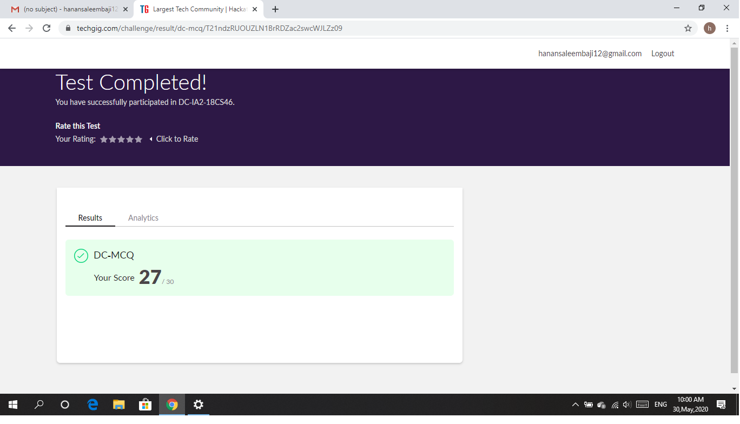

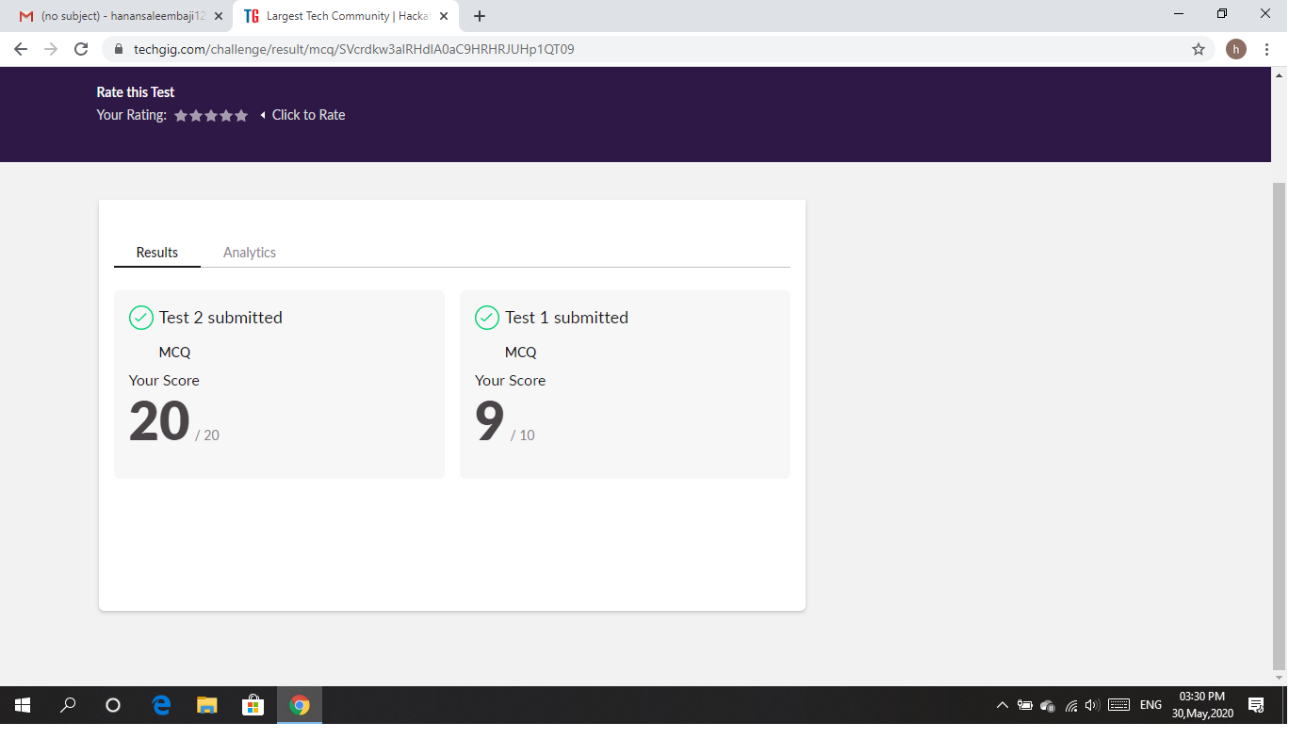

Certification Course Details: Today I have started with Cyber Security certification course. I was able to complete block chain in Cyber Security.

Snapshot:

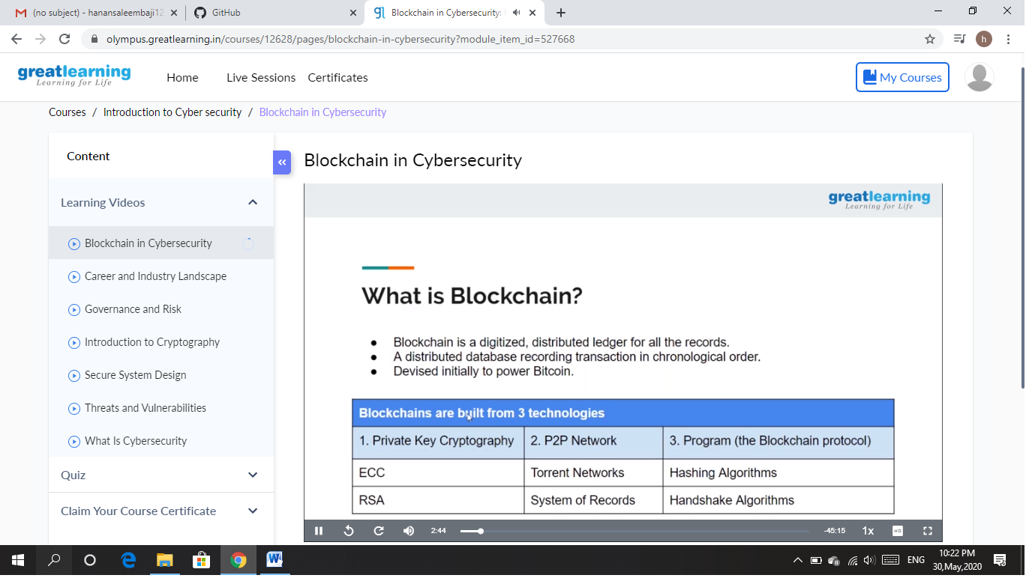

CODING CHALLENGES DETAILS: Problem statements

1. Write a C Program to count Uppercase, Lowercase, special character and numeric values for a given String.

Solution: Uploaded it in github

Snapshot:

